Cairo University  
Faculty of Computers and Information



**CS251**

**Software Engineering I**

Social Network

Software Design

|  |  |
| --- | --- |
| Adham Mamdouh | 20170039 |
| Ahmed Nasr ElDardery | 20170034 |
| Belal Hamdy | 20170077 |
| Abdelrahman Mohamed Hassan | 20170150 |

December/2019

Contents

Team 3

Document Purpose and Audience 3

System Models 4

I. System Decomposition 4

II. Class diagrams 4

III. Class Description and Responsibility Table 5

IV. Sequence diagrams 6

1- Group Creation 6

2- Join Group 6

3- Post to Profile/Page/Group 7

4- Send and Receive Messages 7

5- Login to Account 8

6- Get Posts with Hashtag 8

7- Categorize Post 9

8- Send Friend Request 9

Class - Sequence Usage Table 10

GITHUB 11

Ownership Report 11

# Team

|  |  |  |  |
| --- | --- | --- | --- |
| **ID** | **Name** | **Email** | **Mobile** |
| 20170039 | Adham Mamdouh | Mamdouhadham57@gmail.com | 01111404335 |
| 20170034 | Ahmed Nasr El-dardery | megadardery@yahoo.com | 01142078088 |
| 20170077 | Belal Hamdy Ezzat | belalhezzat@gmail.com | 01120171784 |
| 20170150 | Abdelrahman Mohamed Hassan | Abdookasha01@gmail.com | 01144788185 |

# Document Purpose and Audience

* This document is for illustrating the system design, system composition and sequence diagrams for some use cases.
* Understand some sort of sequences that expected to be in API.
* Illustrates how the classes will communicate.
* Illustrates dependencies between classes.
* Expected audience: System Analyst, Project Manager and lead members.

# System Models

## I. System Decomposition

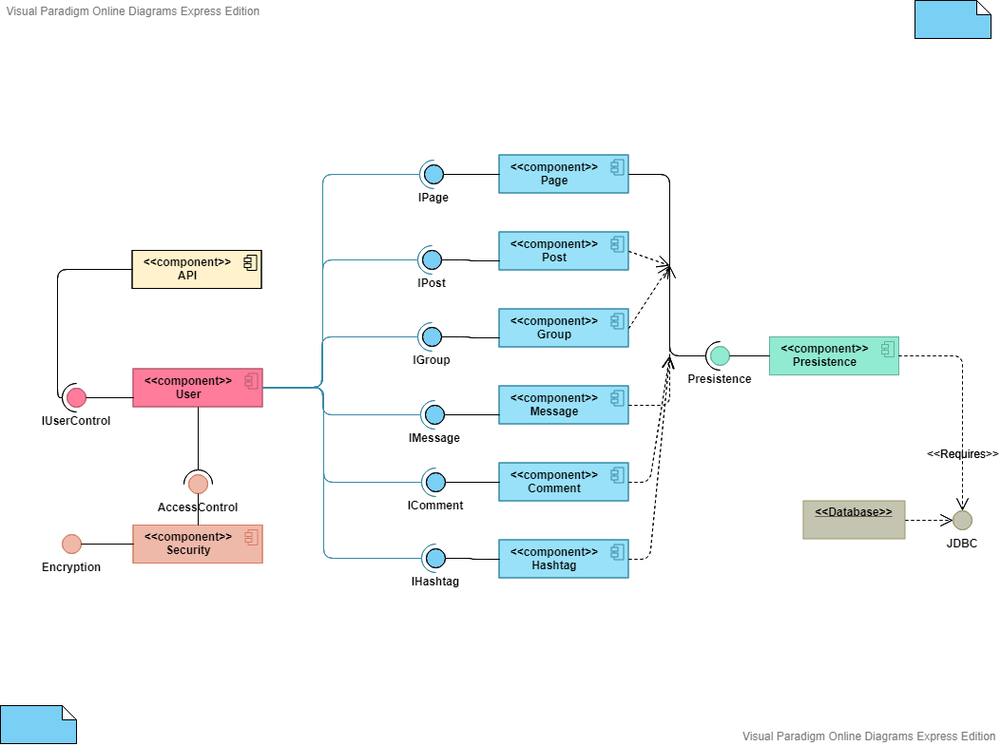

## II. Class diagram

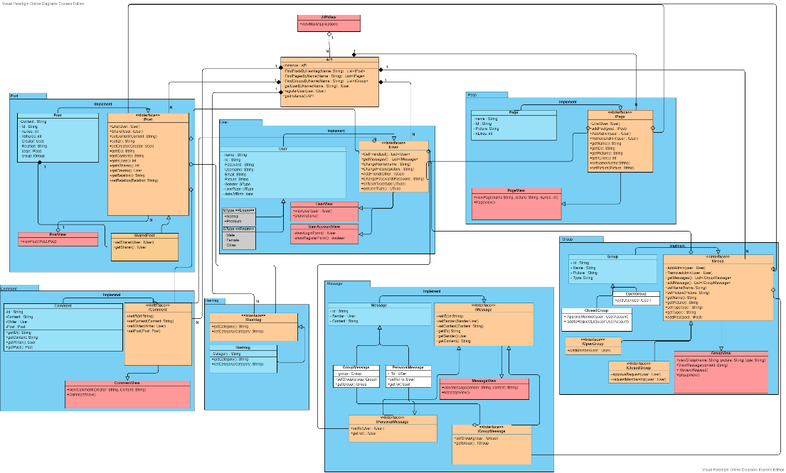

## III. Class Description and Responsibility Table

| **Class ID** | **Class Name** | **Subsystem ID** | **Description & Responsibility** |
| --- | --- | --- | --- |
| API-C1 | API | API-P | This class responsible for managing the interface of system as logging in. |
| Post-C1 | IPost | Post-P | Interface for Posting and its functions. |
| Post-C2 | Post | Post-P | Implements all Posting functions as like post. |
| Post-C3 | SharedPost | Post-P | Shared Post that contains information of post and sharer. |
| Comment-C1 | IComment | Comment-P | Interface for Commenting and its functions. |
| Comment-C2 | Comment | Comment-P | Implements all Commenting functions as write comment. |
| Hashtag-H1 | IHashtag | Hashtag-P | Interface for Hashtag and its functions. |
| Hashtag-H2 | Hashtag | Hashtag-P | Implements Hashtag functions as write setters and getters. |
| User-U1 | IUserAccount | User-P | Interface for Account and its functions. |
| User-U2 | UserAccount | User-P | Implements all Account functions as view account and editing it. |
| User-U3 | NormalUser | User-P | Extends from UserAccount that defines a normal user. |
| User-U4 | SponsoredUser | User-P | Extends from UserAccount that defines a sponsored user. |
| User-U5 | GType | User-P | Enum to define the gender type of a user. |
| Message-C1 | IMessage | Message-P | Interface for messaging and its functions. |
| Message-C2 | Message | Message-P | Implements Message functions like send message. |
| Message-C3 | PresonalMessage | Message-P | Extends from Message that define personal message (message sent to one user). |
| Message-C4 | GroupMessage | Message-P | Extends from Message that define group message (message sent to group of users). |
| Page-C1 | IPage | Page-P | Interface for Pages and their functions. |
| Page-C2 | Page | Page-P | Implements Page functions like Add Admin. |
| Group-C1 | IGroup | Group-P | Interface for Groups and their functions. |
| Group-C2 | Group | Group-P | Implements Group functions as Add Admin. |
| Group-C3 | OpenGroup | Group-P | Default group type that has members and posts and any member can join it anytime. |
| Group-C4 | ClosedGroup | Group-P | Differs from open group in where member cannot join it unless an admin accepts it. |

## IV. Sequence diagrams

### Group Creation

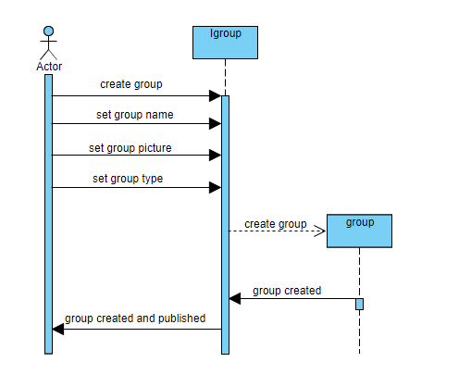

### Join Group

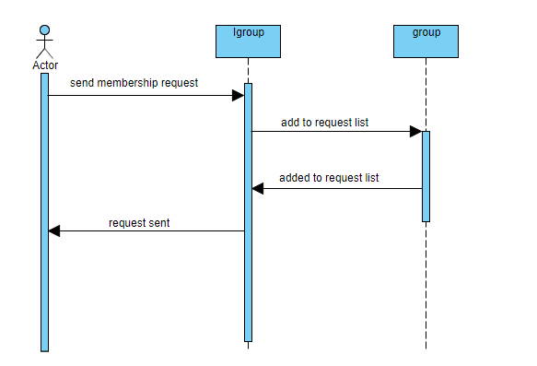

### Post to Profile/Page/Group

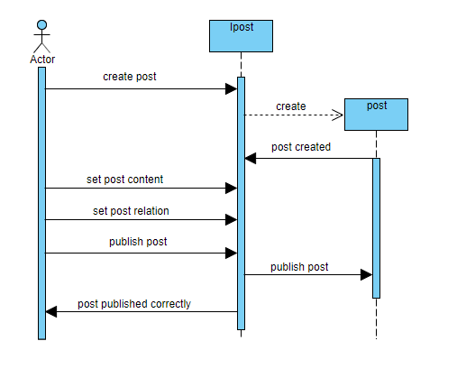

### Send and Receive Messages

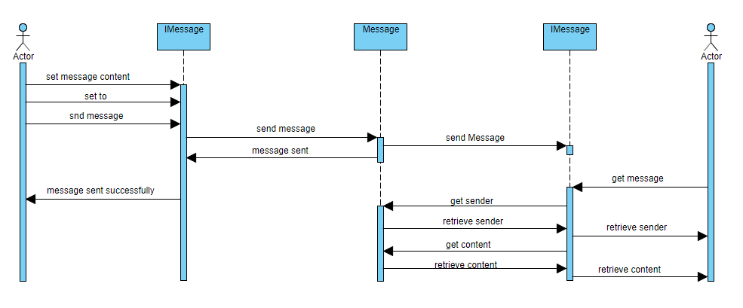

### Login to Account

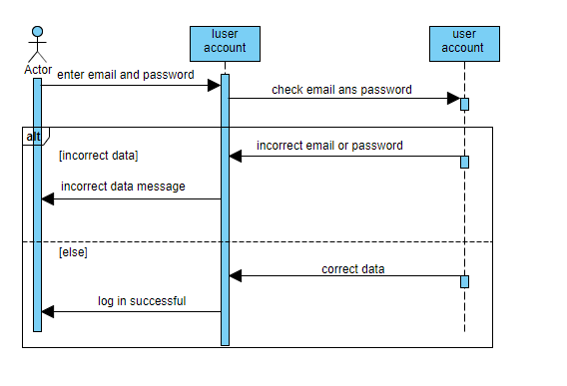

### Get Posts with Hashtag

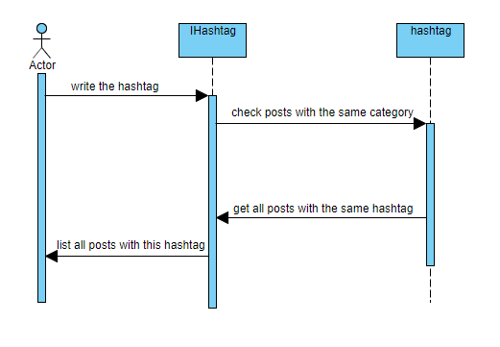

### Categorize Post

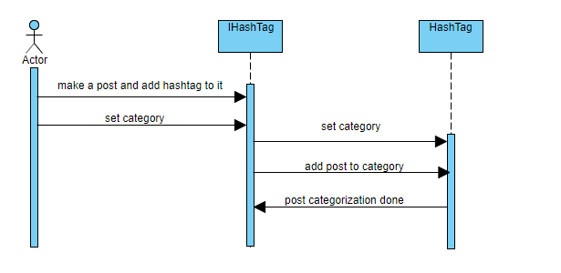

### Send Friend Request

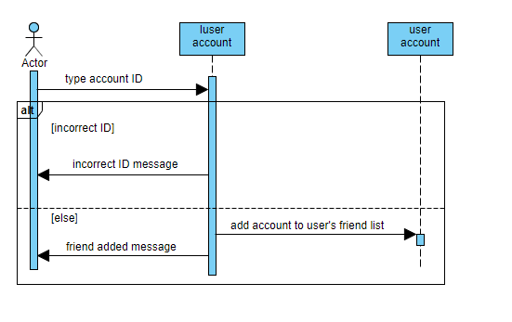

### Class - Sequence Usage Table

| **Class Name** | **Sequence Diagrams** | **Overall used methods** |
| --- | --- | --- |
| User | 1,2 | Create Group, RequestMembership |
| IGroup | 1,2 | CreateGroup, setGroupName, setGroupPicture, setGroupType, RequestMembership |
| Group | 1,2 | CreateGroup, AddToRequestList |
| Post | 3 | CreatePost, setRelation,publishPost |
| IPost | 3 | CreatePost, setRelation,stePostContent, setPostRelation,publishPost |
| IMessage | 4 | setContent,setTo,sendMessage,  getMessage |
| Message | 4 | sendMessage,getSender,getContent |
| IUserAccount | 5 | AddFriend |
| UserAccount | 5 | AddToFriendList |
| API | 6 | CheckEmailAndPassword |
| IHashTag | 7 | checkPostsWithCategory |
| iHashTag | 8 | SetCategory |
| HashTag | 8 | SetCategory,addPostToCategory |

# GITHUB

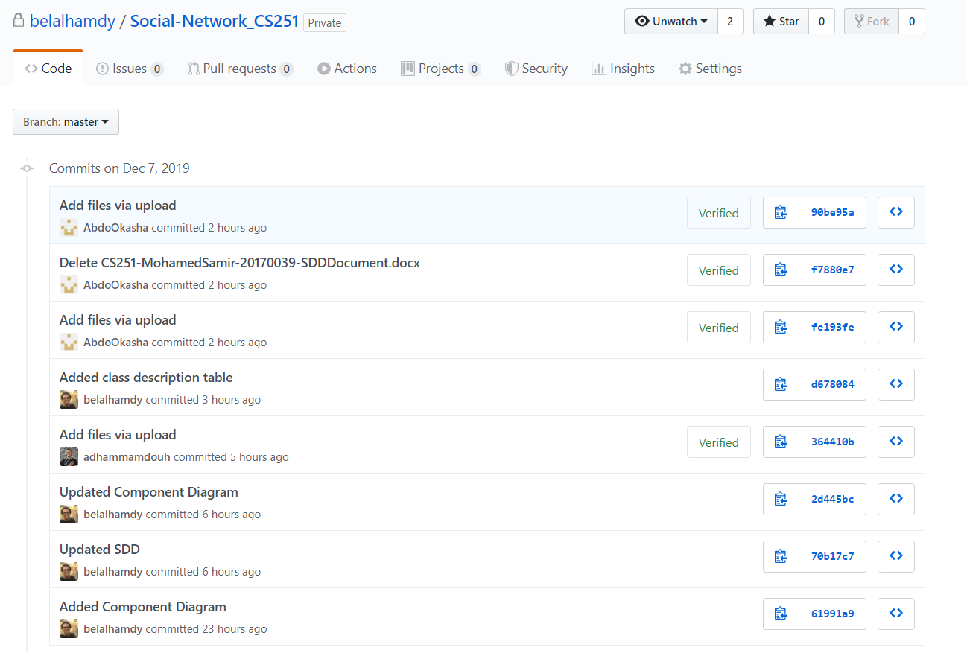

# Ownership Report

|  |  |
| --- | --- |
| **Item** | **Owners** |
| Purpose and Audience, System Decomposition and Class description and responsibility table | *Belal* |
| Class Diagram | *Adham and Belal* |
| Class – sequence Usage Table | *Adham and Abdelrahman* |
| Sequence Diagrams | *Ahmed and Abdelrahman* |